1. Mose 8,9 |  | 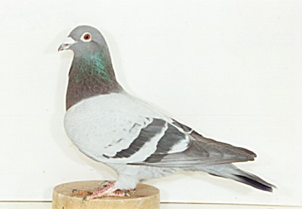
3. Mose 11, 7
Johannes 3,14 |  | 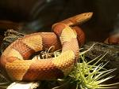
2. Mose 7,28 |  | 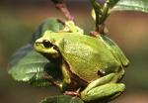
Lukas 15, 4 |  | 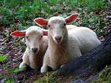
Psalm 104, 21 |  | 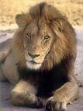

Lukas 16, 21 |  | 
Sprüche 6,6 |  | 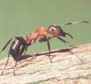
5. Mose 14,14 |  | 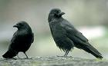
Offenbarung 12, 3 |  | 
Markus 6, 38 |  | 
Lukas 11, 12 |  | 